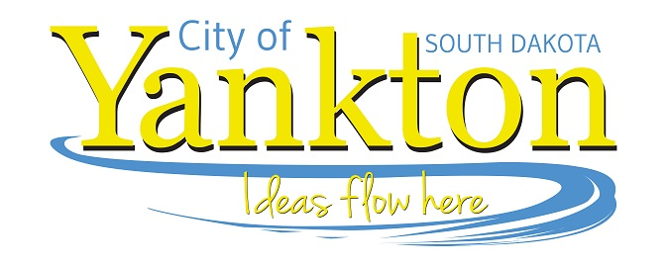
Yankton Community Library 515 Walnut ● Yankton, SD 57078 Phone: 605-668-5276
Dana Schmidt, Director www.cityofyankton.org Fax: 605-668-5277

FOR IMMEDIATE RELEASE
Date: Monday, January 10th at 6:30 pm
Subject: Adult 101: Health and Fitness

Join us for the first installment of Adult 101 at the Yankton Community Library on Monday, January 10th at 6:30 pm. January’s topic is Health and Fitness with Mark “Coach Rozy” Roozen! Adult 101 is a new monthly program series for teens and adults to learn how to navigate some of the overwhelming and confusing parts of adulthood. With this program series, we hope you feel empowered and more confident on the road of adulthood!

For questions, please call the library at 605-668-5275 or email us at library@cityofyankton.org.

