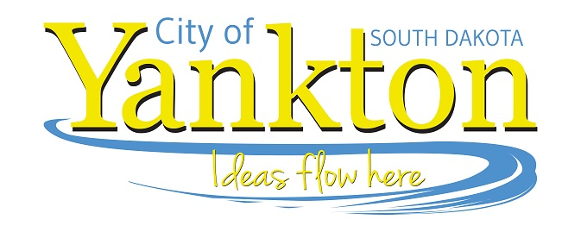
Yankton Community Library 515 Walnut ● Yankton, SD 57078 Phone: 605-668-5276
Dana Schmidt, Director www.cityofyankton.org Fax: 605-668-5277

FOR IMMEDIATE RELEASE
Date: Thursday, February 17th @ 6:30 pm
Subject: Adult Craft Night

The Yankton Community Library will host Adult Craft Night on Thursday, January 20th at 6:30pm. In January we will be creating a large feather design with colorful string. String art is created by wrapping string around different points to create a design. Crafters are welcome to use a feather template or create their own design for this project.

String/yarn, nails and corkboard provided. Registration in person at the library is required for Adult Craft Night.

For questions, please call the library at 605-668-5275 or email us at library@cityofyankton.org.

